New Song News
Colossians 1:15–20 (ESV) ¹⁵He is the image of the invisible God, the firstborn of all creation. ¹⁶For by him all things were created, in heaven and on earth, visible and invisible, whether thrones or dominions or rulers or authorities—all things were created through him and for him. ¹⁷And he is before all things, and in him all things hold together. ¹⁸And he is the head of the body, the church. He is the beginning, the firstborn from the dead, that in everything he might be preeminent. ¹⁹For in him all the fullness of God was pleased to dwell, ²⁰and through him to reconcile to himself all things, whether on earth or in heaven, making peace by the blood of his cross.
Esther 4:13–16 (ESV) ¹³Then Mordecai told them to reply to Esther, “Do not think to yourself that in the king’s palace you will escape any more than all the other Jews. ¹⁴For if you keep silent at this time, relief and deliverance will rise for the Jews from another place, but you and your father’s house will perish. And who knows whether you have not come to the kingdom for such a time as this?” ¹⁵Then Esther told them to reply to Mordecai, ¹⁶“Go, gather all the Jews to be found in Susa, and hold a fast on my behalf, and do not eat or drink for three days, night or day. I and my young women will also fast as you do. Then I will go to the king, though it is against the law, and if I perish, I perish.”

Today
First-time guests, fill out a blue Welcome Card & drop it in the offering plate. We invite you to take one of Pastor Herb’s books as a welcome gift
This week’s Bible Recap readings: The Bible Recap: Read days 256-262, Chronological Guide: p 94-96: boxes for Daniel, p 107, 115, 120-122, 138-141
This Week
Wednesday, 10am, Women’s Bible Study, see Nancy Seman for info.
Thursday, 7pm, Learning Community in person and via Zoom
Friday, 10am, Women’s Bible Study, see Ginger Rogers for info
Friday, 1pm, Learning Community in person and via Zoom
Saturday, 8-9:30a, Monthly Men’s Study
Sunday, 9am, Learning Community.
Looking Ahead
Oct. 3, Bethel Park Rotary Spaghetti Dinner. A “beyond the walls” opportunity to serve the community. Sign up in the lobby.
Volunteers needed to clean the building monthly…
Recycle your aluminum cans – Proceeds support Children of Promise. Bring
them to H.Q. & put them in the wooden enclosure to the left of the front door.

Submit Prayer Requests: email or text newsongpittsburgh@gmail.com
New Song FB Live: https://www.facebook.com/NewSongPittsburgh
Sunday sermons, outlines & other studies can be found on New Song YouTube Channel & Spotify. Use the QR code to access
Gen. Offering | Budget | Family Assistance | Children of Promise | Building Fund
9/6/2026 $ 2,709.00 | $ 4,106.88 | 9/6/2026 $ 0.00 | 9/6/2026 $ 20.00 | 9/6/2026 $ 10.00
To Date $ 156,010.15 | $ 147,847.85 | Balance: $ 2,904.97 | Month Total $ 20.00 | To Date $ 1,910.00
Please print name and amount on offering envelope to receive credit.

New Song Notes Pastor Herb Shaffer

Living God’s Drama Story
September 13, 2026 The Bible Recap Study, week 37
Philippians 2:9–11 ⁹Therefore God has highly exalted him and bestowed on him the name that is above every name, ¹⁰so that at the name of Jesus every knee should bow, in heaven and on earth and under the earth, ¹¹and every tongue confess that Jesus Christ is Lord, to the glory of God the Father. Philippians 2:9–11 (ESV)

Turns out God DOES DO Drama… but of a different kind

it is never about people but about GOD! God is WAY, WAY, WAY BIGGER THAN everything as He works His plan to Messiah Who will bring salvation and restoration. But He partners with people who show us
1. There is always a cost for obeying God
2. We have no idea of the ER & HR ripples from our actions
3. God is glorified through people when they obey in hard circumstances

Finding God’s story for us through the book of Esther

1. Summary of God’s Drama in Esther.

2. Story of God’s Drama in Esther – the story behind the story.
Esther 1-10 (ESV)
pew Bible page 410/ Bible Recap page 1508

Ordinary people

Hard circumstances

Chosen by God

Crisis of belief

God wins and is glorified Earthly Realm and Heavenly Realm

3. Story of God’s Drama with us all.

We are ordinary people God chooses

The drama in our lives is a set-up from God – crisis is opportunity
for God to work toward an ending unknown to us

Our responsibility is to Surrender, Listen and Obey – PERIOD.

What do we do with this?

What stuck out to you?
What is God saying about what stuck out?
What do you need to do in response?



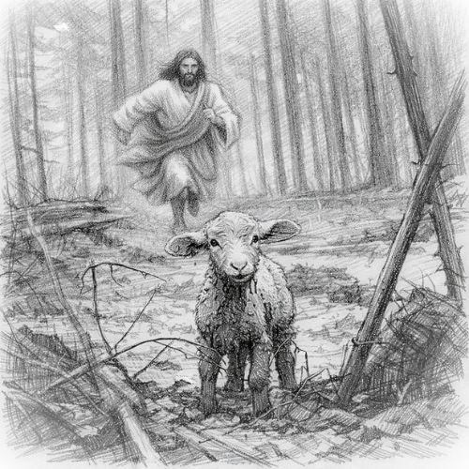

2026

Matthew 20:28 (ESV) “even as the Son of Man came not to be served but to serve, and to give his life as a ransom for many.”

